UNITED STATES

SECURITIES AND EXCHANGE COMMISSION

Washington, D.C. 20549

FORM 8-K/A

(Amendment No. 1)

CURRENT REPORT

Pursuant to Section 13 or 15(d) of the Securities Exchange Act of 1934

Date of Report (Date of earliest event reported): April 1, 2019

THE TORO COMPANY

(Exact name of registrant as Specified in Its Charter)

Delaware | 1-8649 | 41-0580470
(State or Other Jurisdiction of Incorporation) | (Commission File Number) | (I.R.S. Employer Identification No.)
8111 Lyndale Avenue South
Bloomington, Minnesota |  | 55420
(Address of Principal Executive Offices) |  | (Zip Code)
 | (952) 888-8801
 | Registrant's Telephone Number, Including Area Code
 | Not Applicable
 | (Former Name or Former Address, if Changed Since Last Report)

Check the appropriate box below if the Form 8-K filing is intended to simultaneously satisfy the filing obligation of the registrant under any of the following provisions (see General Instructions A.2.

below):

o Written communications pursuant to Rule 425 under the Securities Act (17 CFR 230.425)

o Soliciting material pursuant to Rule 14a-12 under the Exchange Act (17 CFR 240.14a-12)

o Pre-commencement communications pursuant to Rule 14d-2(b) under the Exchange Act (17 CFR 240.14d-2(b))

o Pre-commencement communications pursuant to Rule 13e-4(c) under the Exchange Act (17 CFR 240.13e-4(c))

Securities registered pursuant to Section 12(b) of the Act:

Title of each class | Trading symbol(s) | Name of each exchange on which registered
Common Stock, par value $1.00 per share | TTC | New York Stock Exchange

Indicate by check mark whether the registrant is an emerging growth company as defined in Rule 405 of the Securities Act of 1933 (§230.405 of this chapter) or Rule 12b-2 of the Securities Exchange Act of 1934 (§240.12b-2 of this chapter).

Emerging growth company o

If an emerging growth company, indicate by check mark if the registrant has elected not to use the extended transition period for complying with any new or revised financial accounting standards provided pursuant to Section 13(a) of the Exchange Act. o

Explanatory Note

On April 1, 2019, The Toro Company ("Toro") filed a Current Report on Form 8-K with the Securities and Exchange Commission ("Original 8-K") reporting Toro's acquisition of The Charles Machine Works, Inc. ("CMW"). Toro is filing this Amendment No. 1 to the Original 8-K to amend and supplement the Original 8-K to include financial statements of CMW and pro forma financial information as required by Item 9.01(a) and 9.01(b) of Form 8-K. This Amendment No. 1 should be read together with the Original 8-K.

Section 9 - Financial Statements and Exhibits

Item 9.01 Financial Statements and Exhibits

(a) Financial Statements of Business Acquired

The audited consolidated financial statements of CMW as of and for the years ended December 31, 2018 and 2017 are filed as Exhibit 99.1 to this Amendment No. 1 and incorporated herein by reference.

(b) Pro Forma Financial Information

The unaudited pro forma condensed combined statements of earnings for the six months ended May 3, 2019 and for the fiscal year ended October 31, 2018 and the notes to unaudited pro forma condensed combined financial information, all giving effect to the acquisition of CMW, are filed as Exhibit 99.2 to this Amendment No. 1 and incorporated herein by reference.

- Exhibits

Exhibit No. | Description
23.1 | Consent of Grant Thornton LLP.
99.1 | Audited consolidated financial statements of The Charles Machine Works, Inc. as of and for the years ended December 31, 2018 and 2017.
99.2 | Unaudited pro forma condensed combined statements of earnings for the six months ended May 3, 2019 and for the fiscal year ended
 | October 31, 2018 and the notes to unaudited pro forma condensed combined financial information.

SIGNATURES

Pursuant to the requirements of the Securities Exchange Act of 1934, the Registrant has duly caused this report to be signed on its behalf by the undersigned hereunto duly authorized.

THE TORO COMPANY

(Registrant)

Date: June 13, 2019 /s/ Renee J. Peterson

Renee J. Peterson

Vice President, Treasurer and

Chief Financial Officer

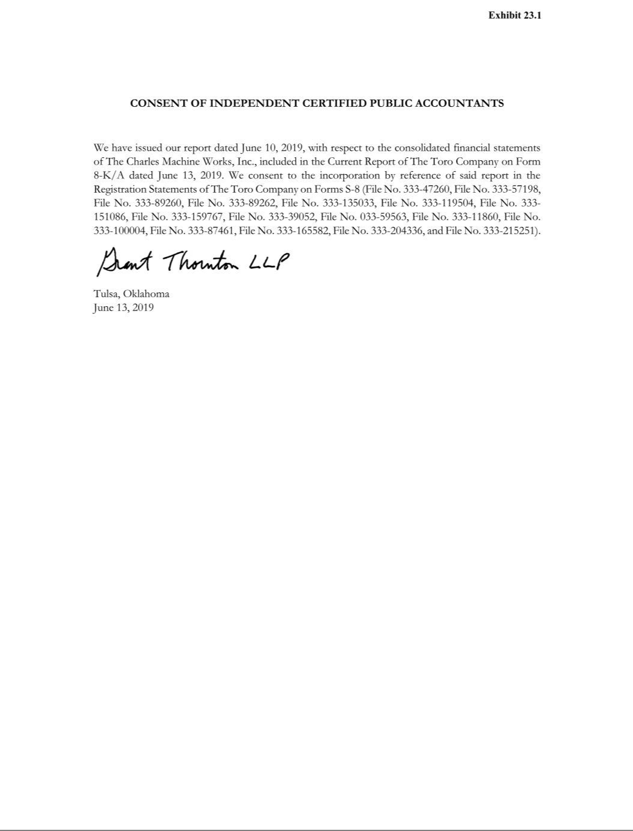

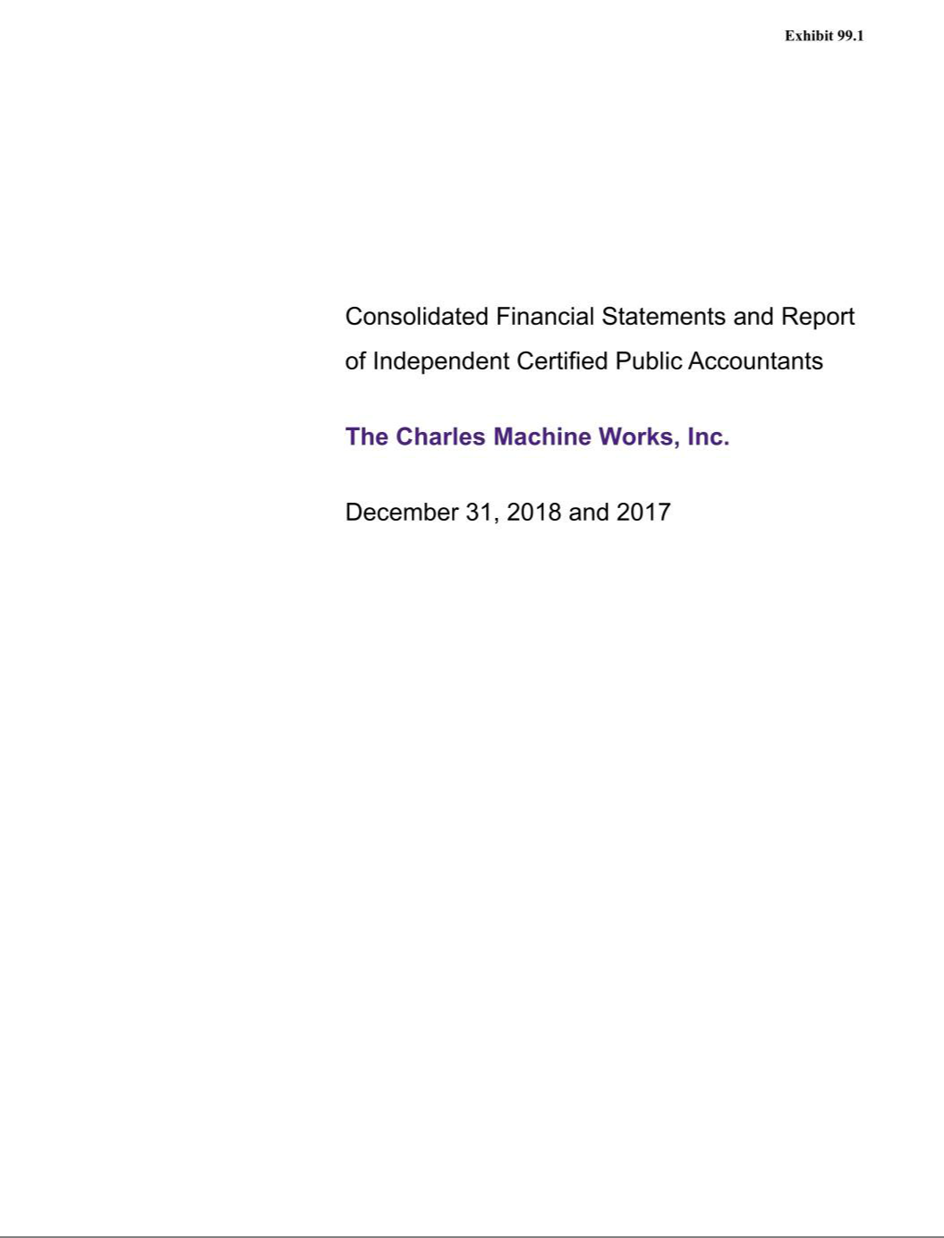

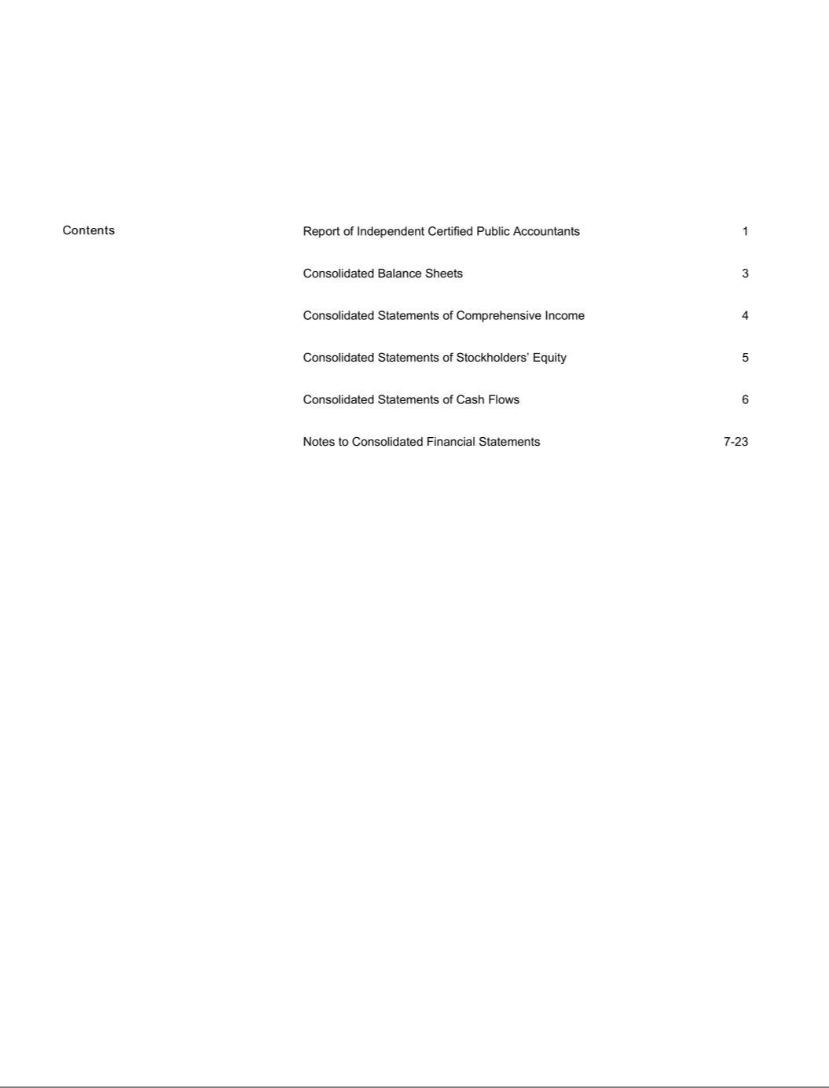

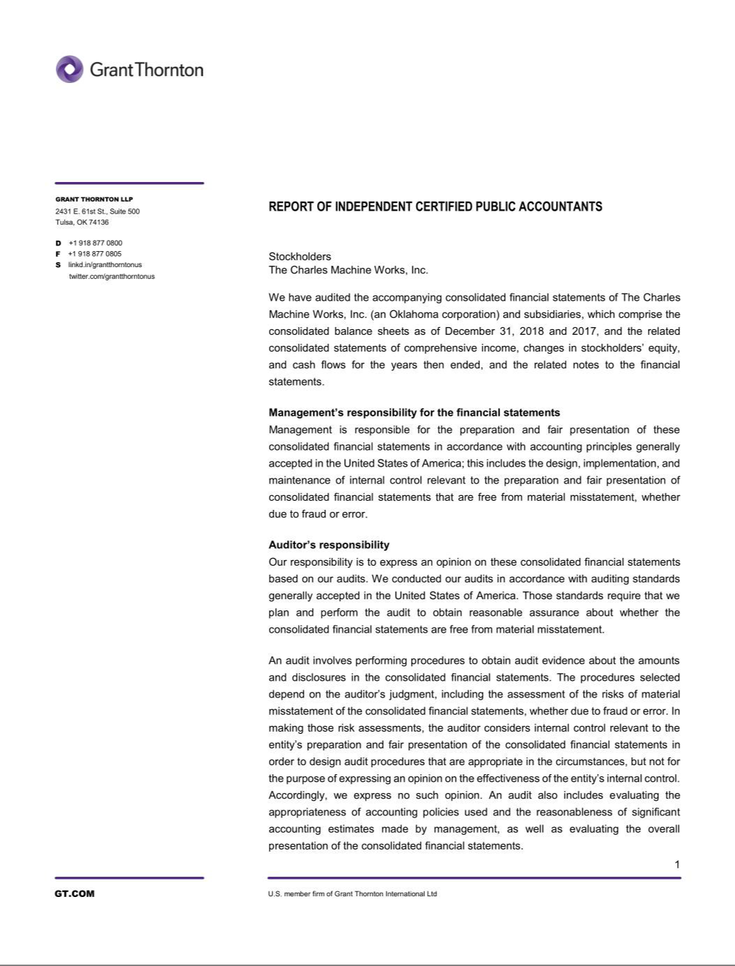

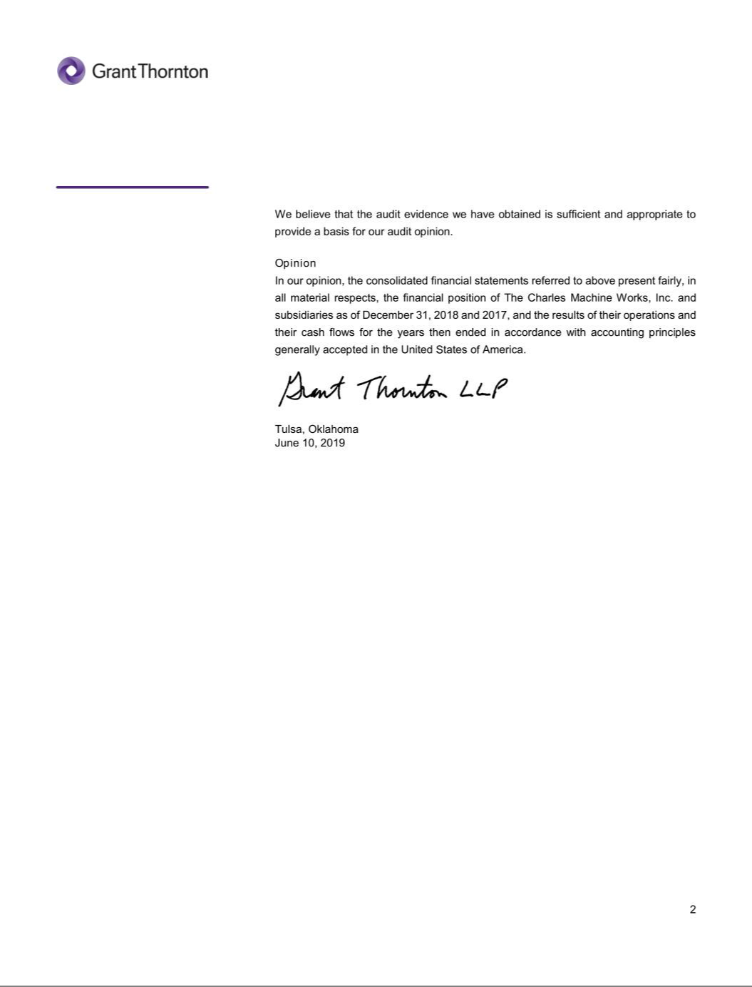

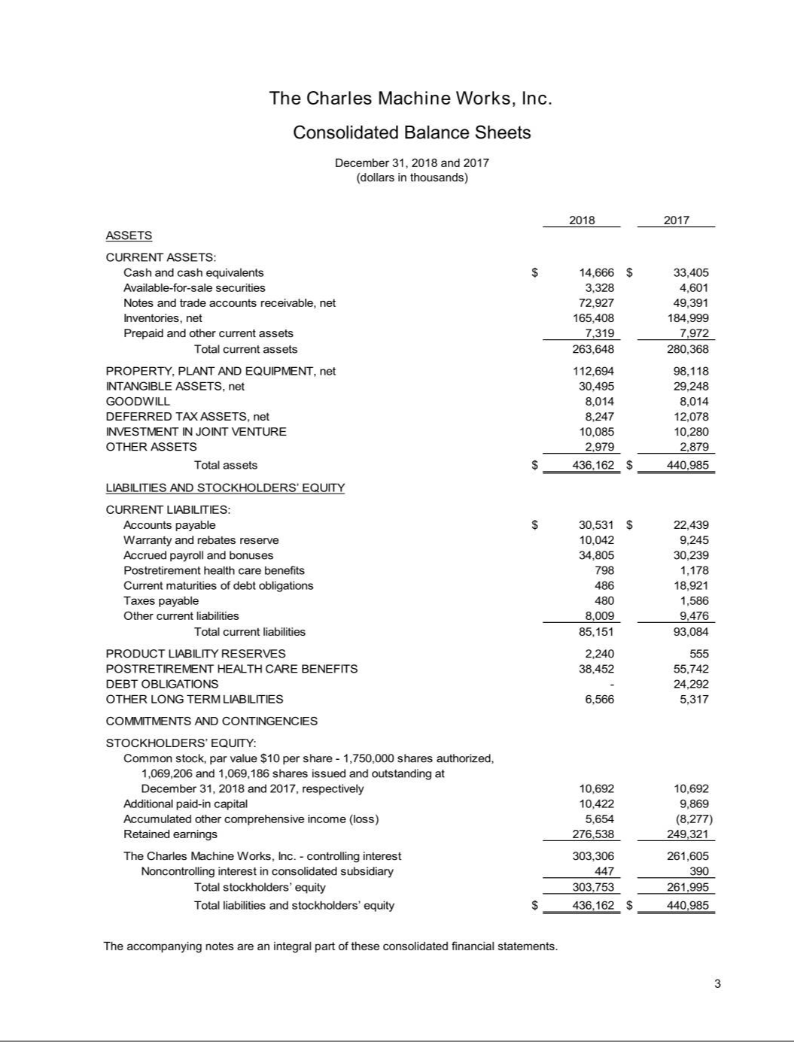

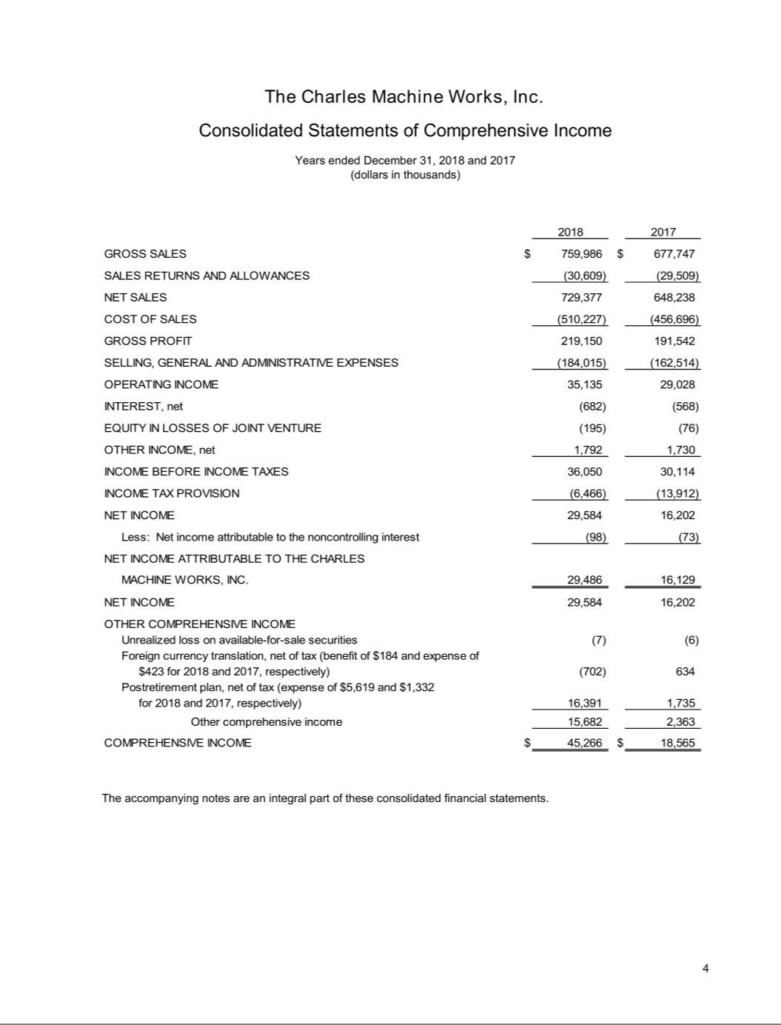

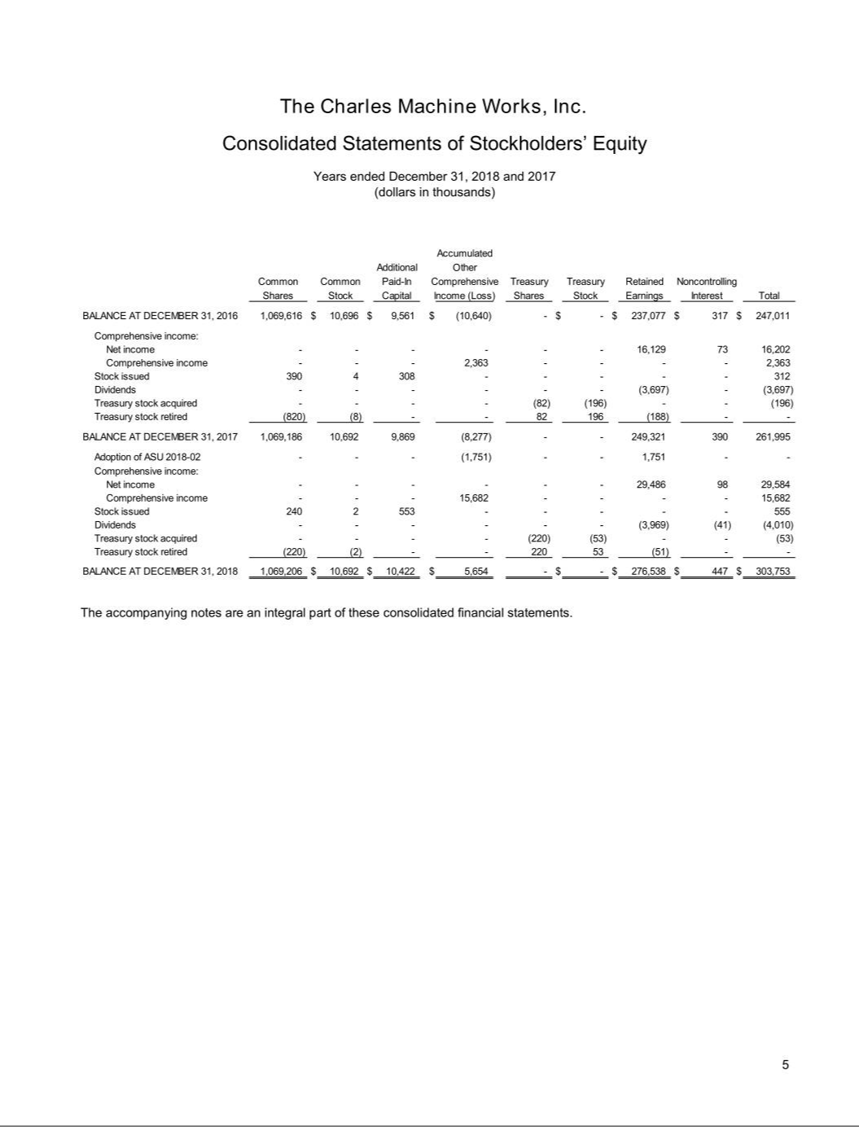

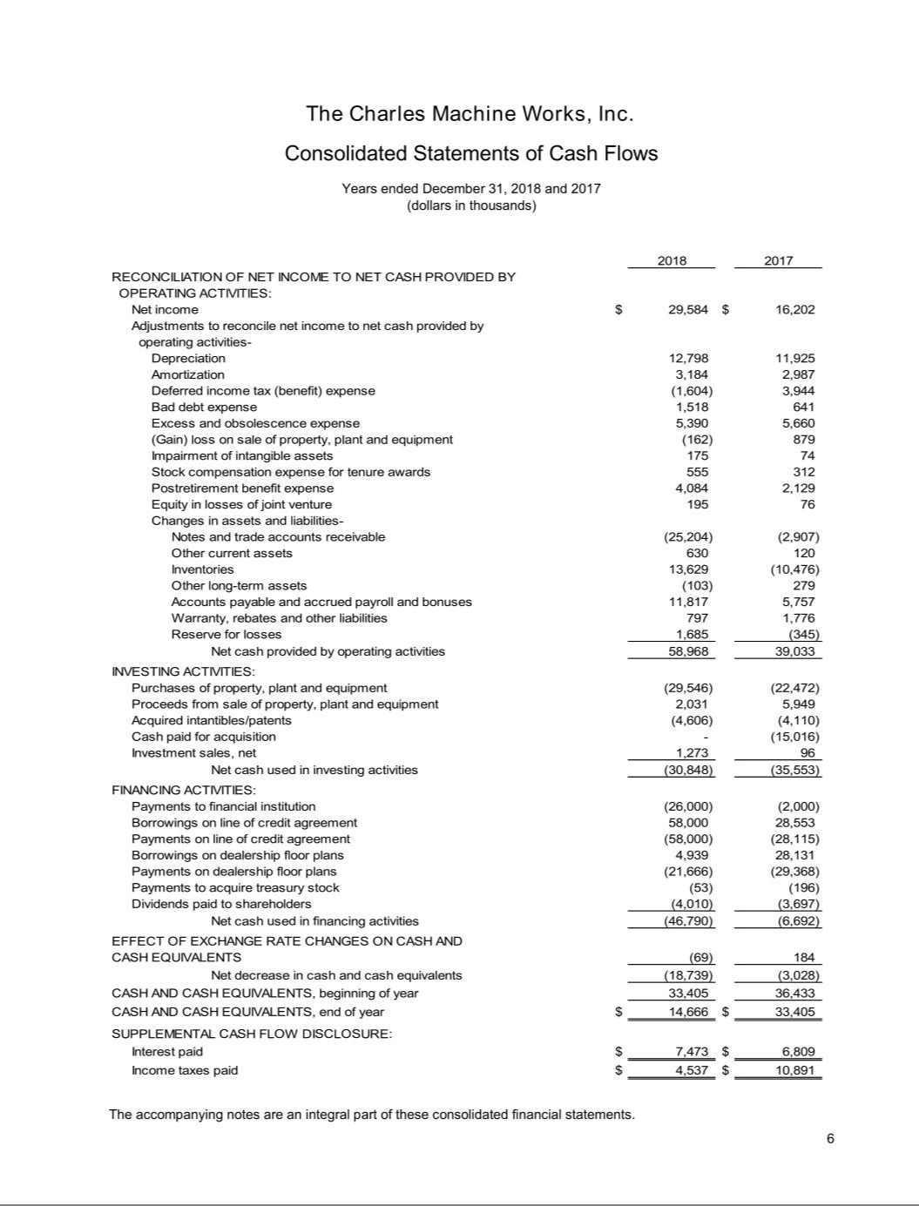

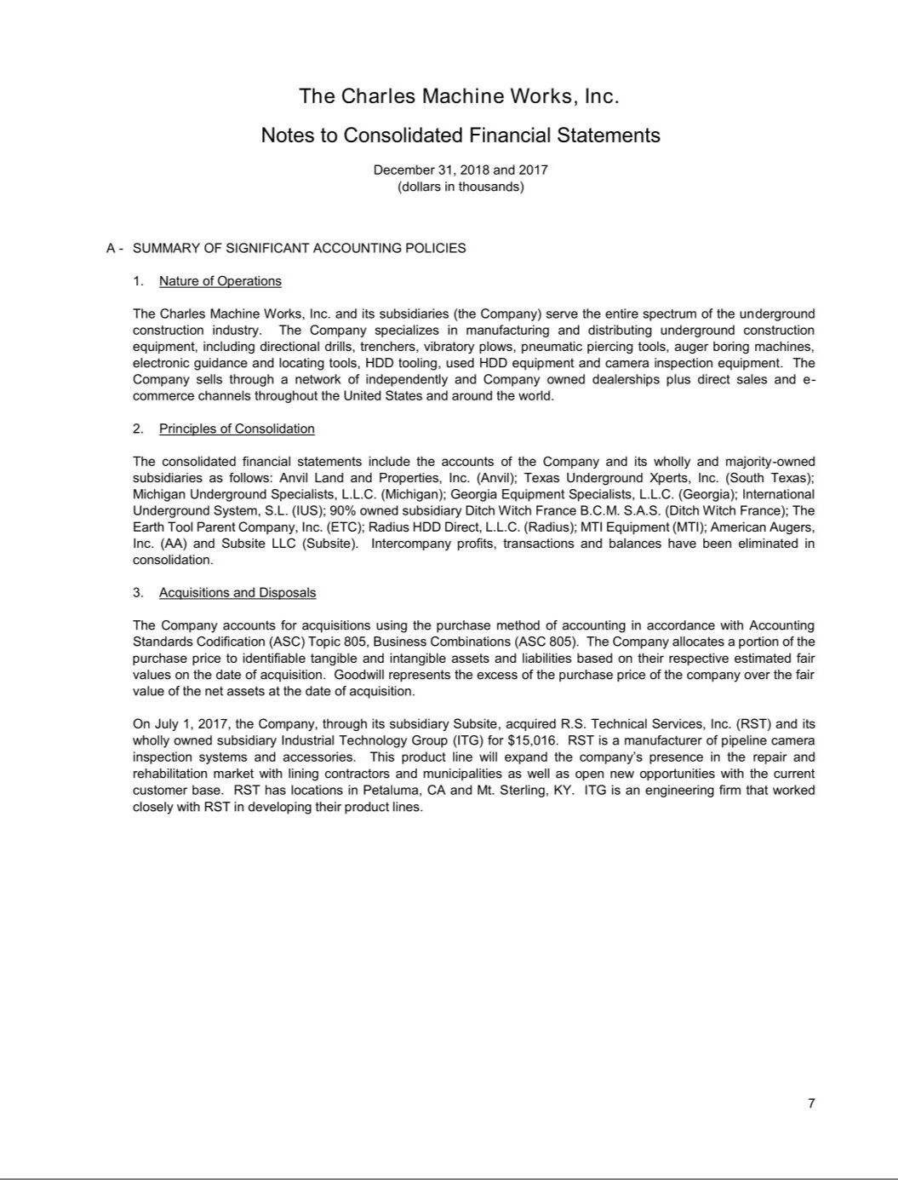

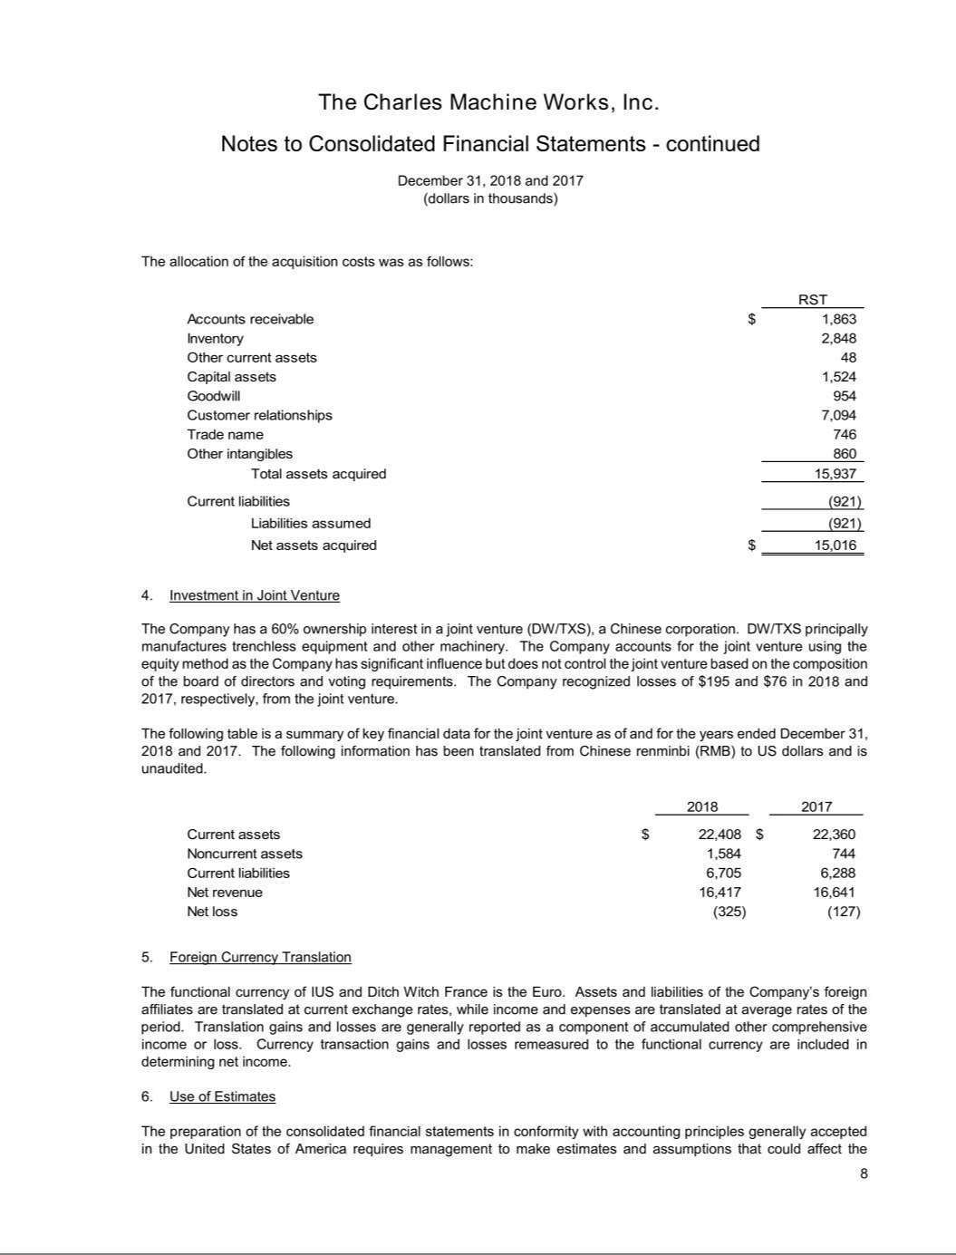

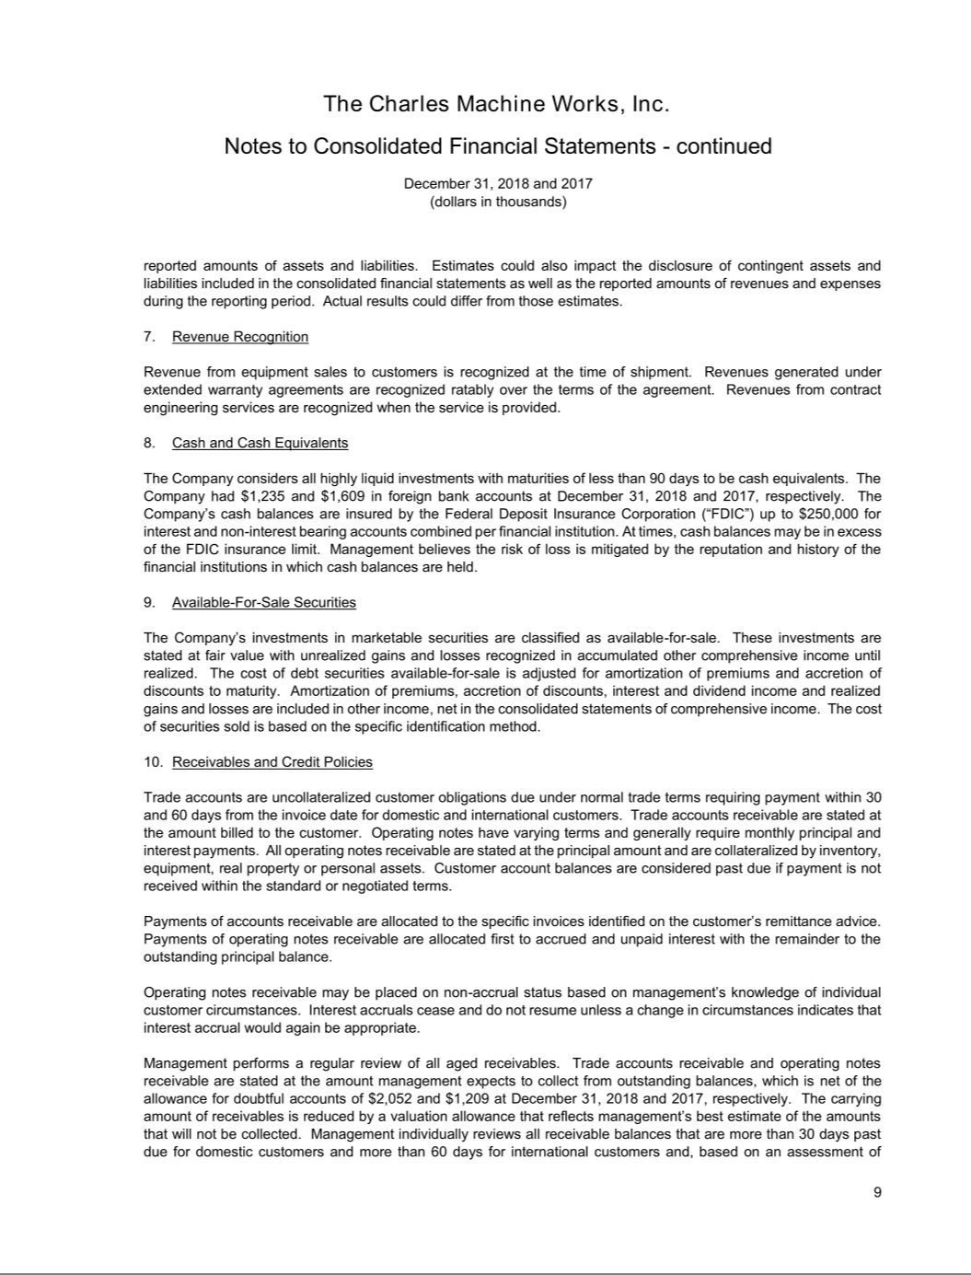

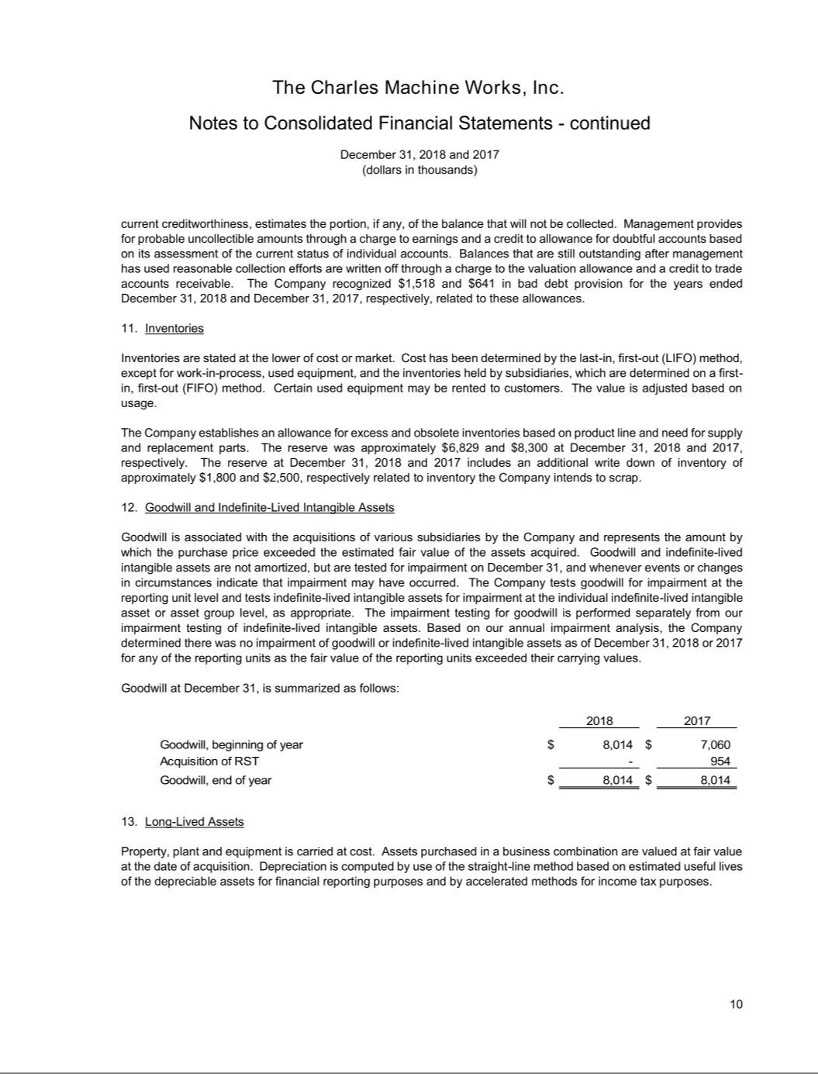

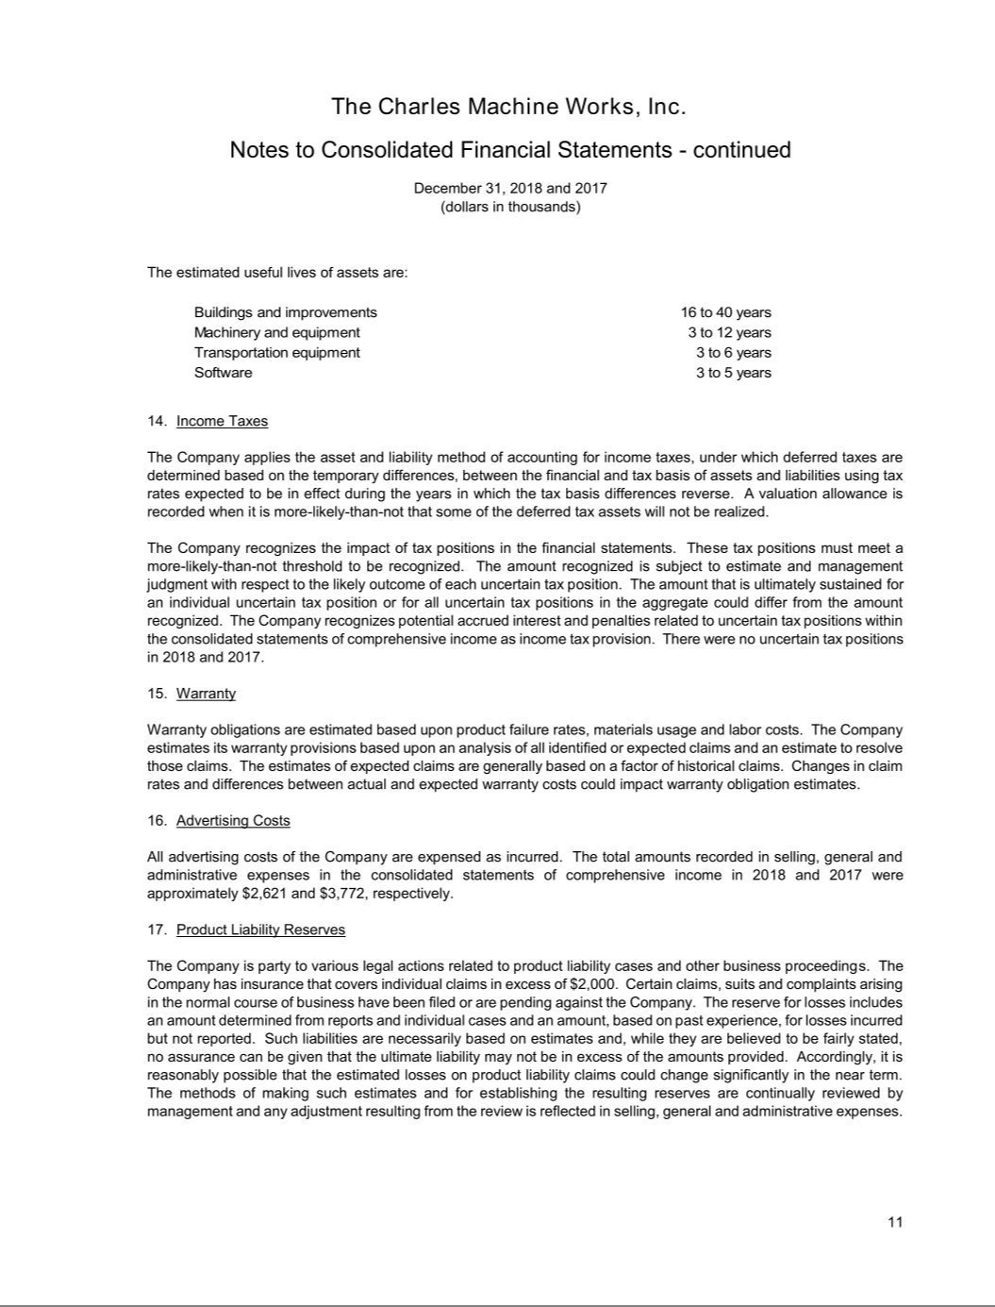

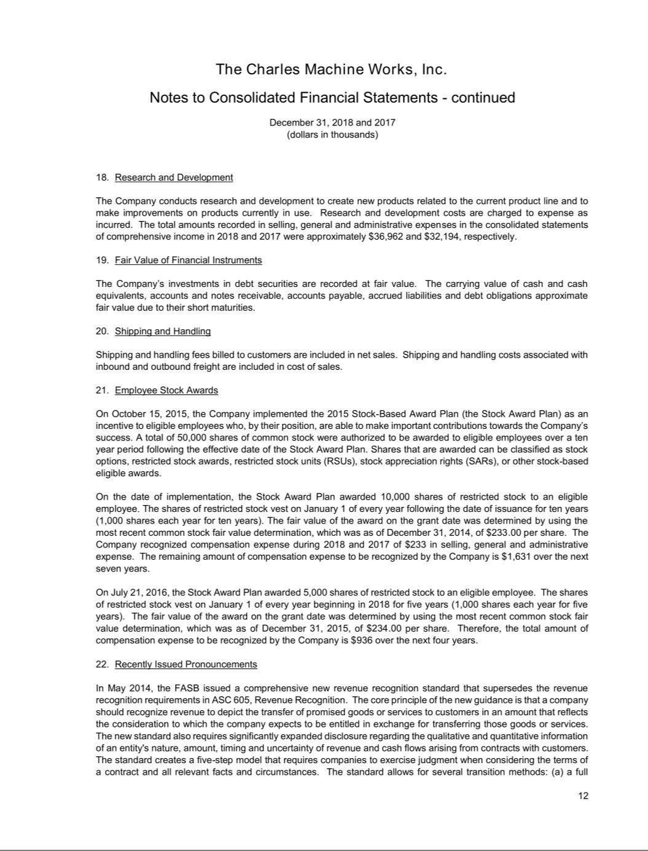

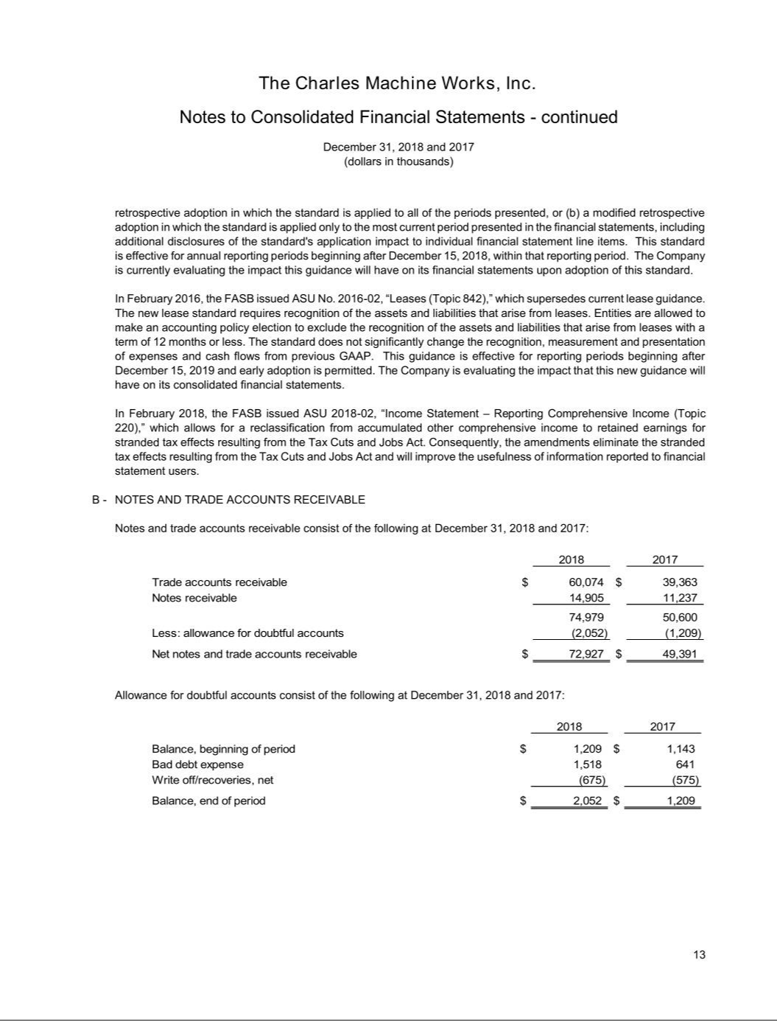

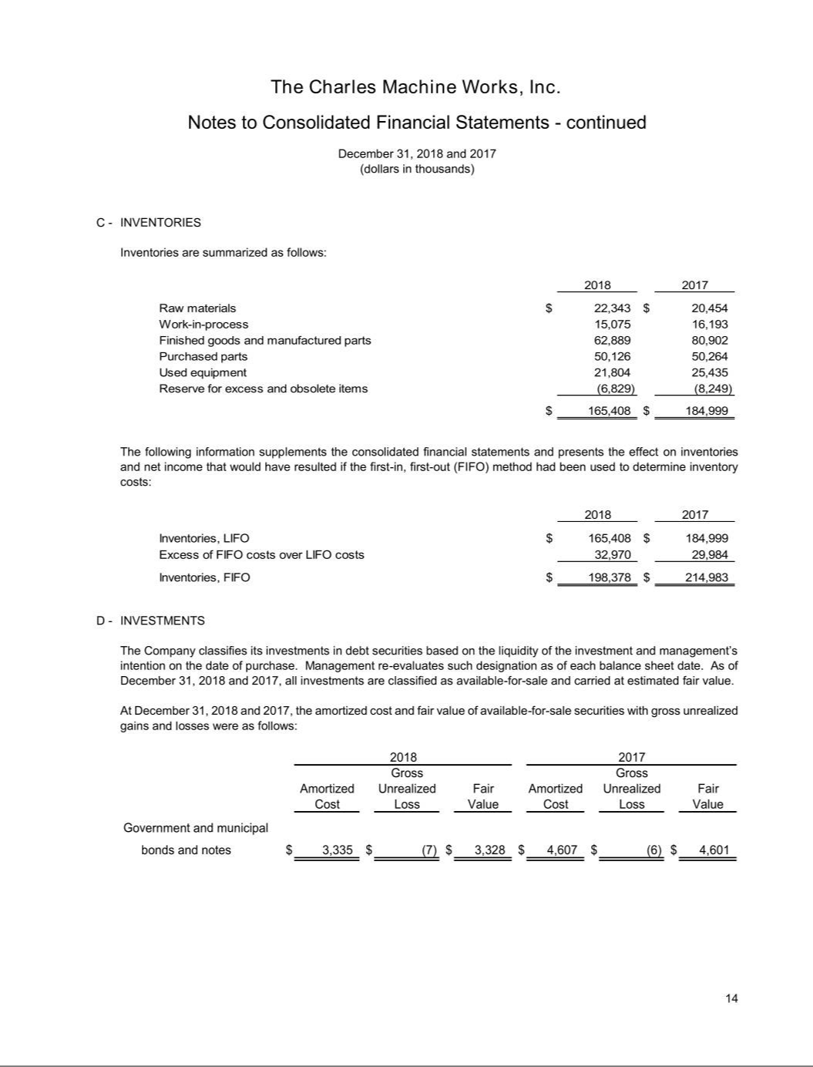

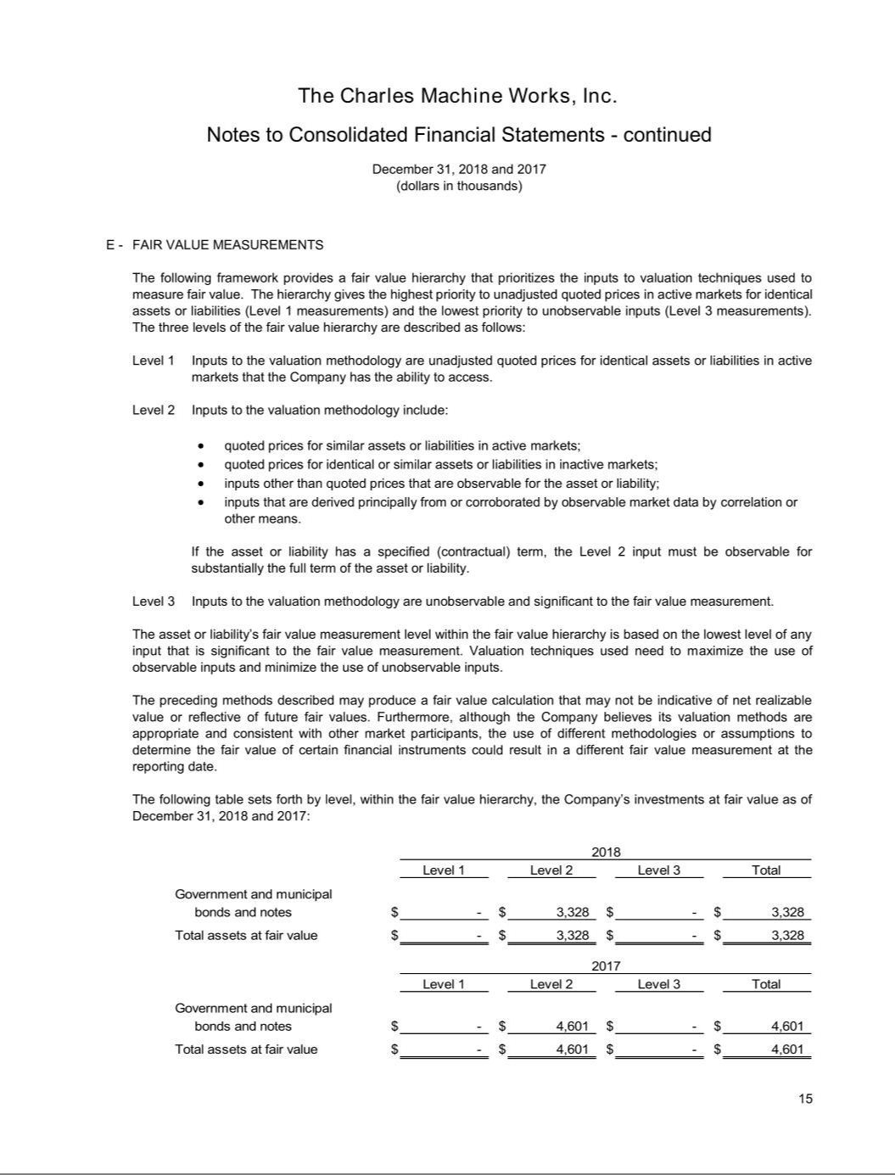

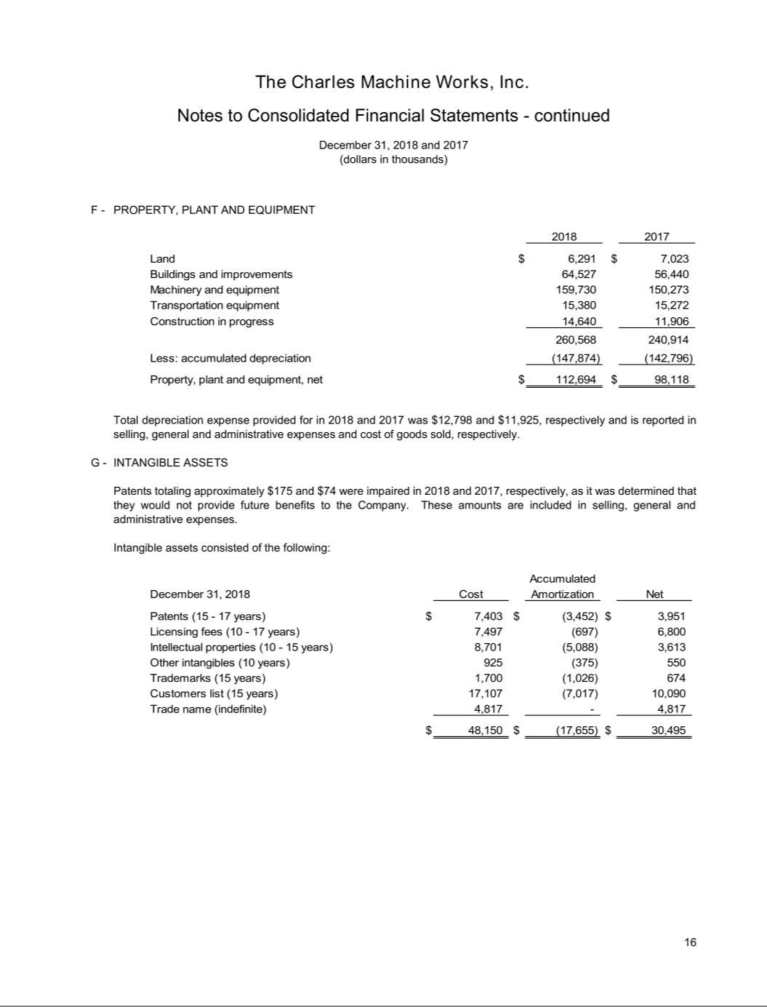

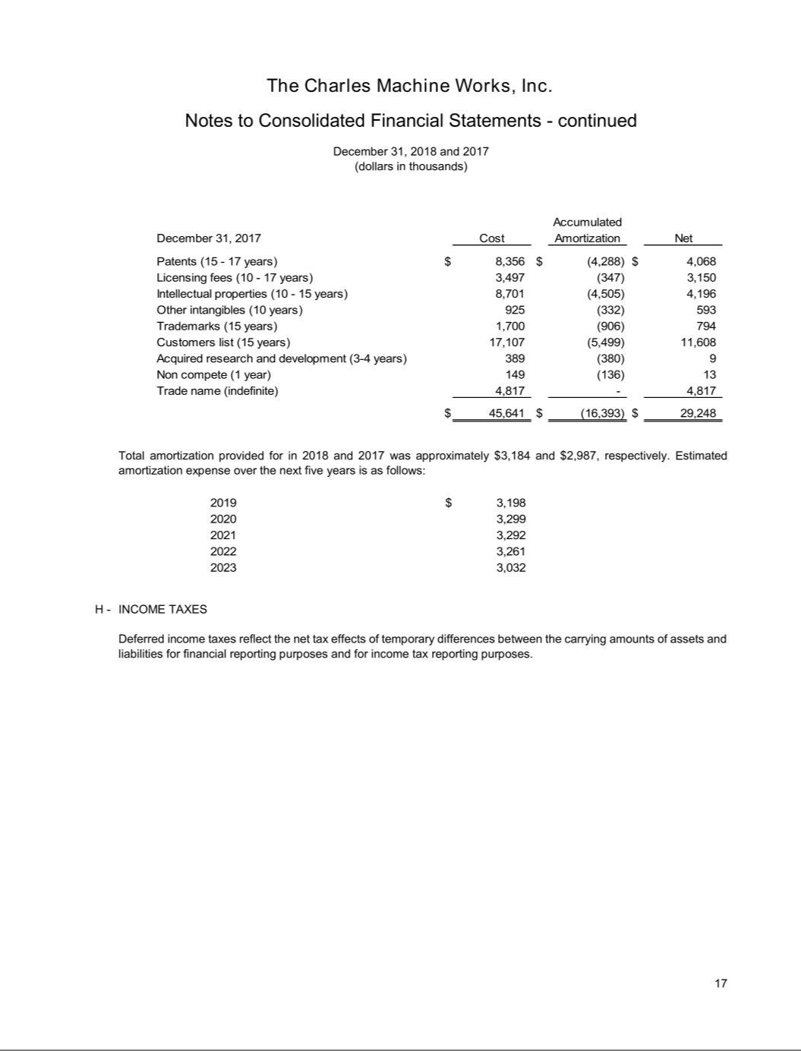

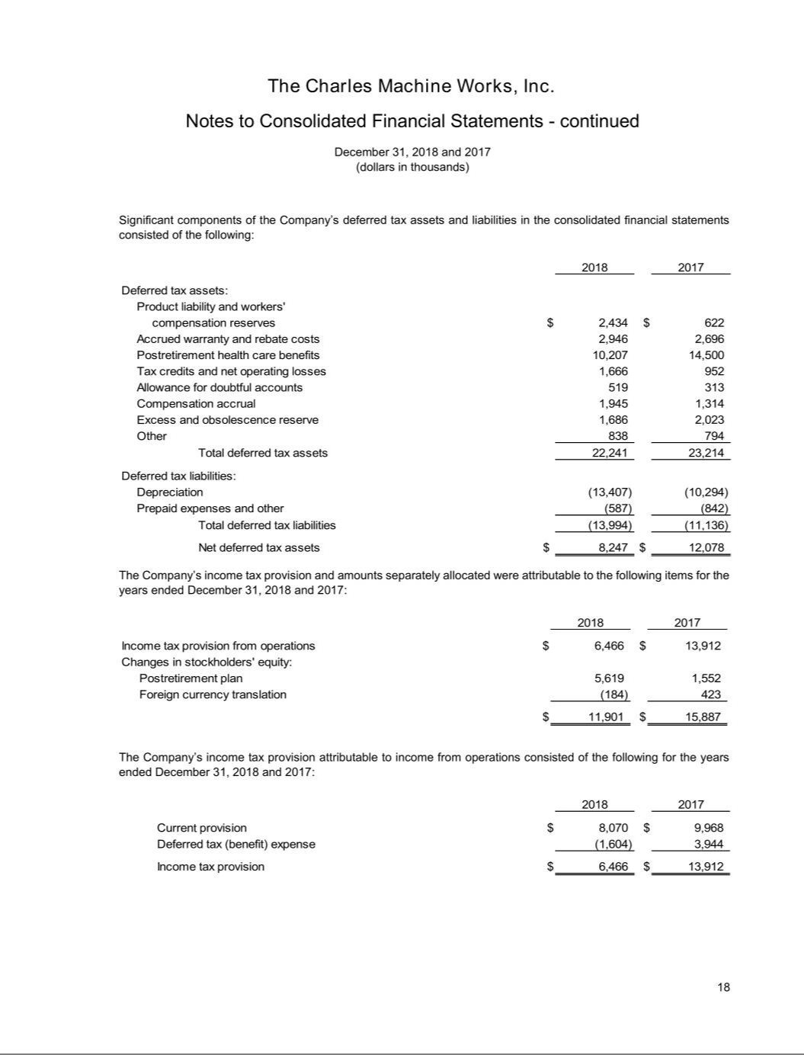

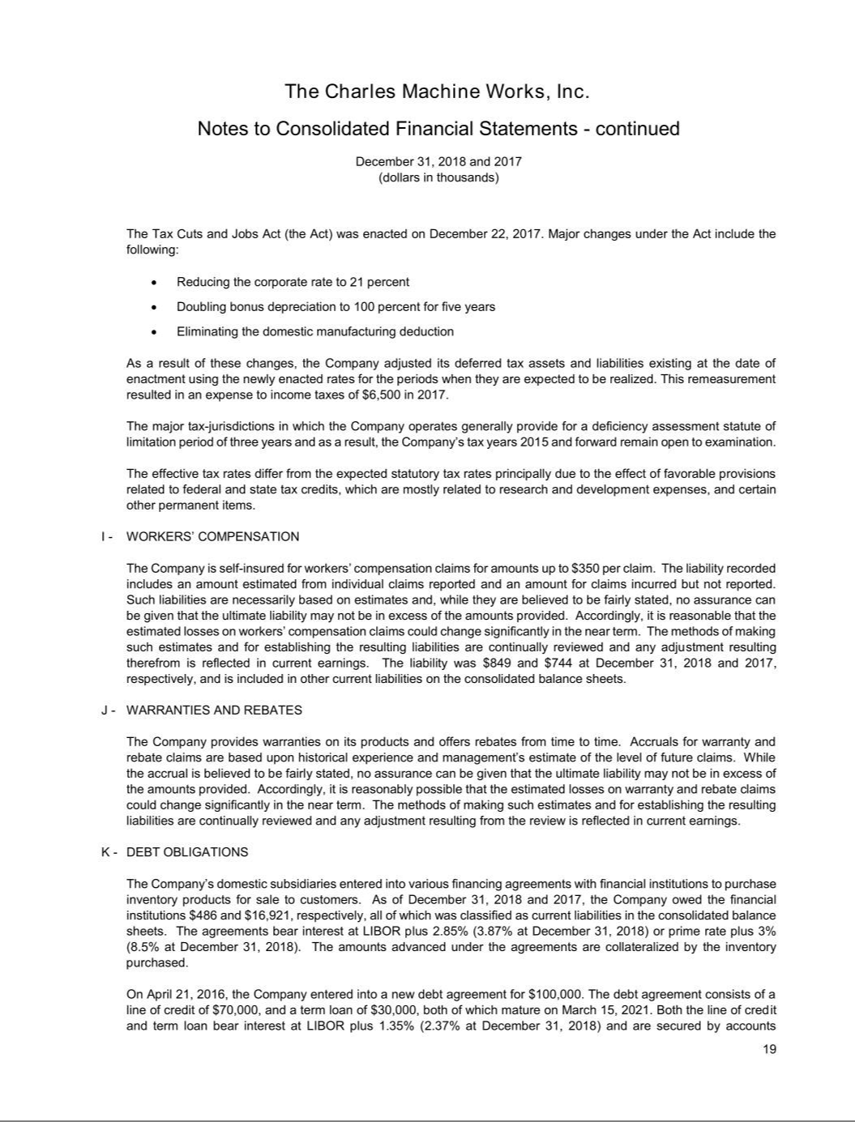

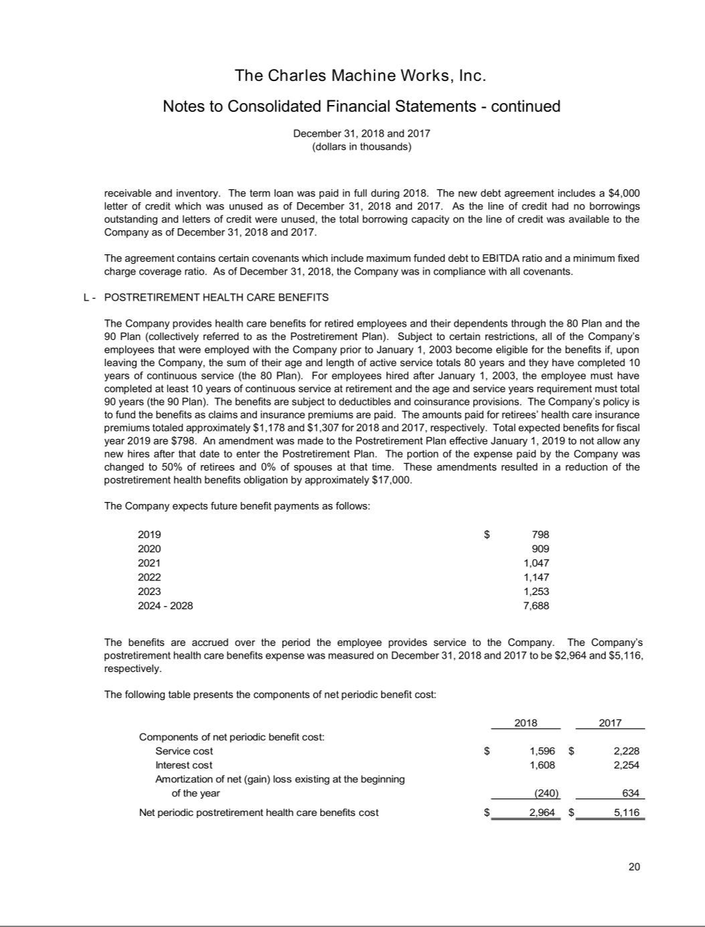

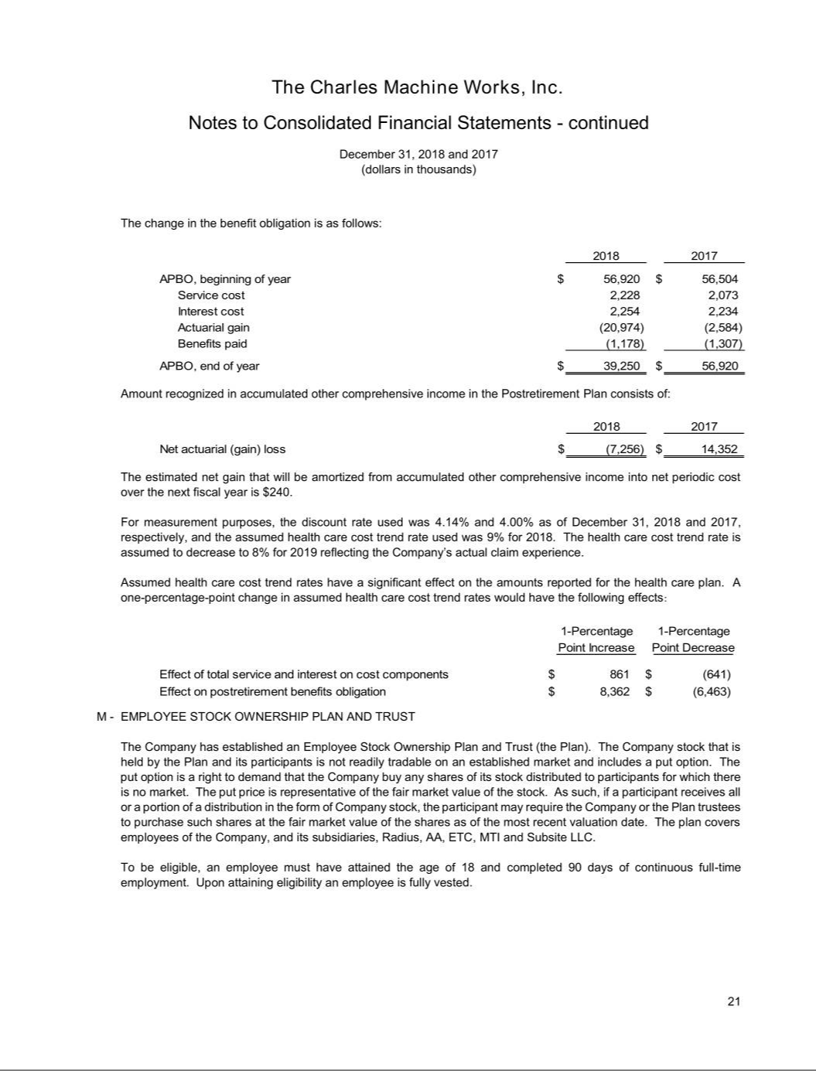

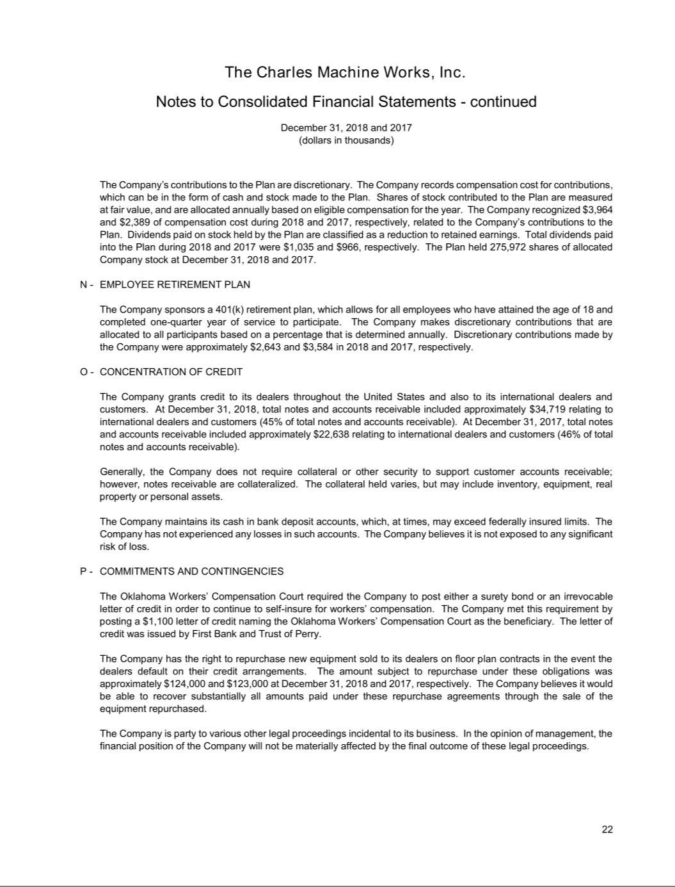

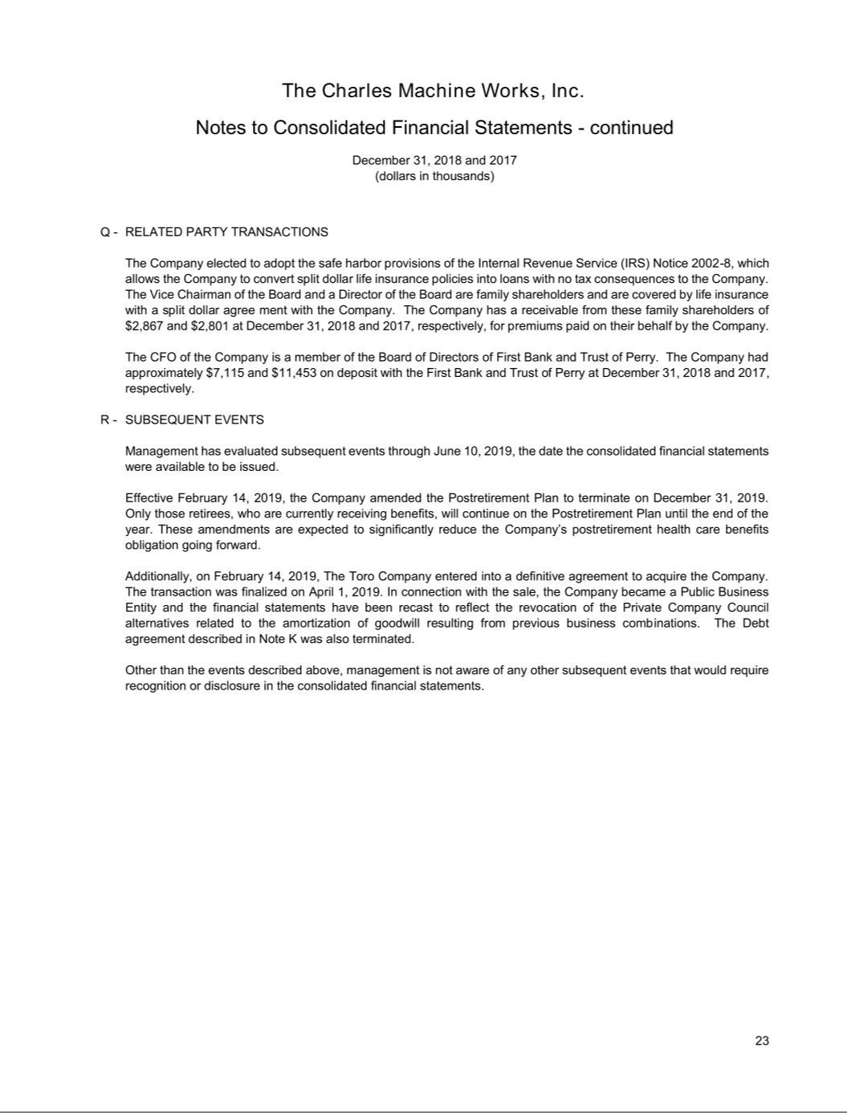

Exhibit 99.2

UNAUDITED PRO FORMA CONDENSED COMBINED FINANCIAL INFORMATION

On April 1, 2019 ("closing date" or "acquisition date"), pursuant to the Agreement and Plan of Merger dated February 14, 2019 ("merger agreement"), The Toro Company ("Toro" or "company") completed the acquisition of The Charles Machine Works, Inc. ("CMW"), a privately held Oklahoma corporation ("acquisition"). The transaction was structured as a merger, pursuant to which a wholly-owned subsidiary of the company merged with and into CMW, with CMW continuing as the surviving entity and a wholly-owned subsidiary of the company. As a result of the merger, all of the outstanding equity securities of CMW were canceled and now only represent the right to receive the applicable consideration as described in the merger agreement. The preliminary aggregate merger consideration was $679.6 million ("purchase price"), and remains subject to customary adjustments based on, among other things, the amount of actual cash, debt and working capital in the business of CMW at the closing date. The company funded the preliminary purchase price for the acquisition by using cash proceeds from the issuance of $500 million of borrowings under the company's unsecured senior term loan credit agreement, which included a $200 million three year unsecured senior term loan maturing on April 1, 2022 and a $300 million five year unsecured senior term loan maturing on April 1, 2024. The residual balance of the preliminary purchase price of $179.6 million was funded through cash proceeds from borrowings on the company's unsecured senior revolving credit facility.

The following Unaudited Pro Forma Condensed Combined Financial Information is based on the historical Consolidated Financial Statements of Toro and CMW after giving effect to the acquisition and the assumptions and adjustments described in the accompanying Notes to Unaudited Pro Forma Condensed Combined Financial Information.

The Unaudited Pro Forma Condensed Combined Statements of Earnings were prepared in accordance with Article 11 of Securities and Exchange Commission ("SEC") Regulation S-X and the acquisition method of accounting in accordance with the accounting standards codification guidance for business combinations, with Toro being the acquiring entity. The Unaudited Pro Forma Condensed Combined Statements of Earnings reflect estimates and assumptions deemed appropriate by company management to give effect to the acquisition as if it had been completed effective as of November 1, 2017, the beginning of Toro's fiscal 2018.

The Unaudited Pro Forma Condensed Combined Statements of Earnings and related Notes to Unaudited Pro Forma Condensed Combined Financial Information have been prepared utilizing period ends that differ by 93 days or less, as permitted by Regulation S-X. Toro reports annual financial results on a fiscal year ending October 31, and quarterly results are reported based on three-month periods that generally end on the Friday closest to the quarter end. For comparative purposes, however, Toro’s second and third quarters always include exactly 13 weeks of results so that the quarter end date for these two quarters is not necessarily the Friday closest to the calendar month end. CMW reports on a calendar year ending December 31 and accordingly, April 30, 2019 was the period end closest to Toro's fiscal second quarter ended May 3, 2019. This reporting period difference is not material to the Unaudited Pro Forma Condensed Combined Statements of Earnings for the six months ended May 3, 2019.

The Unaudited Pro Forma Condensed Combined Statements of Earnings for the six months ended May 3, 2019 includes (i) Toro's results of operations for the six months ended May 3, 2019, which are inclusive of CMW's results of operations from the acquisition date through April 30, 2019, and (ii) CMW's results of operations for the period November 1, 2018 through the acquisition date. The Unaudited Pro Forma Condensed Combined Statements of Earnings for the fiscal year ended October 31, 2018 includes (i) Toro's results of operations for the fiscal year ended October 31, 2018 and (ii) CMW's results of operations for the calendar year ended December 31, 2018.

The preliminary allocation of the purchase price used in the Unaudited Pro Forma Condensed Combined Financial Information, and described within Note 3 of the Notes to Unaudited Pro Forma Condensed Combined Financial Information, is based upon preliminary estimates. The preliminary estimated fair values of certain assets and liabilities have been determined with the assistance of a third-party valuation firm and such firm's preliminary work. Toro's estimates and assumptions are subject to change during the measurement period (up to one year from the acquisition date) as Toro finalizes the valuations of certain tangible and intangible assets acquired and liabilities assumed in connection with the acquisition. The company believes that the information available as of the closing date provides a reasonable basis for estimating the fair values of the assets acquired and liabilities assumed; however, the company is continuing to finalize these amounts, particularly with respect to income taxes and valuations of inventories, fixed assets, and intangible assets.

The Unaudited Pro Forma Condensed Combined Financial Information has been presented for informational purposes only. The Unaudited Pro Forma Condensed Combined Statements of Earnings and related Notes to Unaudited Pro Forma Condensed Combined Financial Information are not necessarily indicative of the results that would have been achieved had the acquisition actually taken place on November 1, 2017, the first day of Toro's fiscal 2018, and accordingly, do not purport to be indicative of future Consolidated Results of Operations. The Unaudited Pro Forma Condensed Combined Statement of Earnings and Notes to

Unaudited Pro Forma Condensed Combined Financial Information do not reflect any synergies, operating efficiencies, and/or cost savings that may be realized from the integration of the acquisition.

The Unaudited Pro Forma Condensed Combined Statements of Earnings and Notes to Unaudited Pro Forma Condensed Combined Financial Information should be read in conjunction with:

- The historical Consolidated Financial Statements of Toro included in the Annual Report on Form 10-K for the year ended October 31, 2018 filed with the SEC on December 21, 2018;

- Toro's subsequent Quarterly Reports on Form 10-Q for the fiscal quarter ended February 1, 2019 and fiscal quarter ended May 3, 2019 filed with the SEC on March 6, 2019 and June 5, 2019, respectively; and

- The historical consolidated financial statements of CMW for the calendar years ended December 31, 2018 and 2017 included within Exhibit 99.1 of this Current Report on Form 8-K/A.

A pro forma condensed combined balance sheet is not required within this Unaudited Pro Forma Condensed Combined Financial Information as Toro's acquisition of CMW has already been reflected within Toro's historical Condensed Consolidated Balance Sheet as of May 3, 2019, included in the company’s Quarterly Report on Form 10-Q for the fiscal quarter ended May 3, 2019, and filed with the SEC on June 5, 2019.

THE TORO COMPANY AND SUBSIDIARIES

Unaudited Pro Forma Condensed Combined Statements of Earnings

Six Months Ended May 3, 2019

(Dollars and shares in thousands, except per share data)

 |  | Historical Results (Note 2) |  |  |  |  | Pro Forma
 |  | Toro |  | CMW |  | Adjustments | Note 4 | Combined
Net sales | $ | 1,564,992 | $ | 299,251 | $ | — | $ | 1,864,243
Cost of sales |  | 1,028,077 |  | 211,040 |  | (8,422) | [A] | 1,230,695
 |  |  |  |  |  | 701 | [B] | 701
 |  |  |  |  |  | (1,097) | [C] | (1,097)
Gross profit |  | 536,915 |  | 88,211 |  | 8,818 |  | 633,944
Selling, general and administrative expense (Note 5) |  | 329,136 |  | 35,488 |  | 774 | [B] | 365,398
 |  |  |  |  |  | 3,473 | [C] | 3,473
 |  |  |  |  |  | (12,250) | [D] | (12,250)
Operating earnings |  | 207,779 |  | 52,723 |  | 16,821 |  | 277,323
Interest (expense) income |  | (11,436) |  | 31 |  | (10,139) | [E] | (21,544)
Other income, net |  | 10,857 |  | 992 |  |  |  | 11,849
Earnings before income taxes |  | 207,200 |  | 53,746 |  | 6,682 |  | 267,628
Provision for income taxes |  | 32,090 |  | 1,427 |  | 707 | [F] | 34,224
Net earnings | $ | 175,110 | $ | 52,319 | $ | 5,975 | $ | 233,404
Basic net earnings per share of common stock | $ | 1.64 |  |  |  |  | $ | 2.19
Diluted net earnings per share of common stock | $ | 1.62 |  |  |  |  | $ | 2.16
Weighted-average number of shares of common stock outstanding — Basic |  | 106,466 |  |  |  |  |  | 106,466
Weighted-average number of shares of common stock outstanding — Diluted |  | 107,909 |  |  |  |  |  | 107,909

See accompanying Notes to Unaudited Pro Forma Condensed Combined Financial Information.

THE TORO COMPANY AND SUBSIDIARIES

Unaudited Pro Forma Condensed Combined Statements of Earnings

Fiscal Year Ended October 31, 2018

(Dollars and shares in thousands, except per share data)

 |  | Historical Results (Note 2) |  |  |  |  | Pro Forma
 |  | Toro |  | CMW |  | Adjustments | Note 4 | Combined
Net sales | $ | 2,618,650 | $ | 729,377 | $ | — | $ | 3,348,027
Cost of sales |  | 1,677,639 |  | 510,227 |  | 1,681 | [B] | 2,189,547
Gross profit |  | 941,011 |  | 219,150 |  | (1,681) |  | 1,158,480
Selling, general and administrative expense |  | 567,926 |  | 184,015 |  | 1,858 | [B] | 753,799
 |  |  |  |  |  | 7,183 | [C] | 7,183
 |  |  |  |  |  | (663) | [D] | (663)
Operating earnings |  | 373,085 |  | 35,135 |  | (10,059) |  | 398,161
Interest expense |  | (19,096) |  | (682) |  | (23,649) | [E] | (43,427)
Other income, net |  | 18,408 |  | 1,499 |  |  |  | 19,907
Earnings before income taxes |  | 372,397 |  | 35,952 |  | (33,708) |  | 374,641
Provision for income taxes |  | 100,458 |  | 6,466 |  | (5,174) | [F] | 101,750
Net earnings | $ | 271,939 | $ | 29,486 | $ | (28,534) | $ | 272,891
Basic net earnings per share of common stock | $ | 2.56 |  |  |  |  | $ | 2.57
Diluted net earnings per share of common stock | $ | 2.50 |  |  |  |  | $ | 2.51
Weighted-average number of shares of common stock outstanding — Basic |  | 106,369 |  |  |  |  |  | 106,369
Weighted-average number of shares of common stock outstanding — Diluted |  | 108,657 |  |  |  |  |  | 108,657

See accompanying Notes to Unaudited Pro Forma Condensed Combined Financial Information.

THE TORO COMPANY AND SUBSIDIARIES

Notes to Unaudited Pro Forma Condensed Combined Financial Information

Note 1 - Description of Transaction

On April 1, 2019 ("closing date" or "acquisition date"), pursuant to the Agreement and Plan of Merger dated February 14, 2019 ("merger agreement"), The Toro Company ("Toro" or "company") completed the acquisition of The Charles Machine Works, Inc. ("CMW"), a privately held Oklahoma corporation ("acquisition"). The transaction was structured as a merger, pursuant to which a wholly-owned subsidiary of the company merged with and into CMW, with CMW continuing as the surviving entity and a wholly-owned subsidiary of the company. As a result of the merger, all of the outstanding equity securities of CMW were canceled and now only represent the right to receive the applicable consideration as described in the merger agreement. The preliminary aggregate merger consideration was $679.6 million ("purchase price"), and remains subject to customary adjustments based on, among other things, the amount of actual cash, debt and working capital in the business of CMW at the closing date. The company funded the preliminary purchase price for the acquisition by using cash proceeds from the issuance of $500 million of borrowings under the company's unsecured senior term loan credit agreement, which included a $200 million three year unsecured senior term loan maturing on April 1, 2022 and a $300 million five year unsecured senior term loan maturing on April 1, 2024. The residual balance of the preliminary purchase price of $179.6 million was funded through cash proceeds from borrowings on the company's unsecured senior revolving credit facility.

Note 2 - Basis of Presentation

The Unaudited Pro Forma Condensed Combined Statements of Earnings were prepared in accordance with Article 11 of Securities and Exchange Commission ("SEC") Regulation S-X and the acquisition method of accounting in accordance with the accounting standards codification guidance for business combinations, with Toro being the acquiring entity. The Unaudited Pro Forma Condensed Combined Statements of Earnings reflect estimates and assumptions deemed appropriate by company management to give effect to the acquisition as if it had been completed effective as of November 1, 2017, the beginning of Toro's fiscal 2018.

The Unaudited Pro Forma Condensed Combined Statements of Earnings were prepared using the historical financial information of Toro and CMW, both of which are presented in accordance with generally accepted accounting principles in the United States of America. Certain reclassifications have been made to CMW's historical financial statements to conform to the presentation used in Toro's historical Consolidated Financial Statements. The historical financial information of Toro and CMW was adjusted to give effect to the transactions that are (i) directly attributable to the acquisition, (ii) factually supportable, and (iii) expected to have a continuing impact on the operating results of the combined company. Nonrecurring charges or credits and related tax effects, which result directly from the acquisition and do not have a continuing impact as they will be included in the earnings of the company within the 12 months following the acquisition, are not included in the Unaudited Pro Forma Condensed Combined Statements of Earnings.

Toro reports annual financial results on a fiscal year ending October 31, and quarterly results are reported based on three-month periods that generally end on the Friday closest to the quarter end. For comparative purposes, however, Toro’s second and third quarters always include exactly 13 weeks of results so that the quarter end date for these two quarters is not necessarily the Friday closest to the calendar month end. CMW reports on a calendar year ending December 31 and accordingly, April 30, 2019 was the period end closest to Toro's fiscal second quarter ended May 3, 2019. This reporting period difference is not material to the Unaudited Pro Forma Condensed Combined Statements of Earnings for the six months ended May 3, 2019.

The Unaudited Pro Forma Condensed Combined Statements of Earnings for the six months ended May 3, 2019 includes (i) Toro's results of operations for the six months ended May 3, 2019, which are inclusive of CMW's results of operations from the acquisition date through April 30, 2019, and (ii) CMW's results of operations for the period November 1, 2018 through the acquisition date. The Unaudited Pro Forma Condensed Combined Statements of Earnings for the fiscal year ended October 31, 2018 includes (i) Toro's results of operations for the fiscal year ended October 31, 2018 and

- CMW's results of operations for the calendar year ended December 31, 2018. To align periods, the results of CMW for the months of November 2018 and December 2018 are included in the Unaudited Pro Forma Condensed Combined Statements of Earnings for both the six month period ended May 3, 2019 and the fiscal year ended October 31, 2018. The net sales and net earnings for CMW for the combined months of November 2018 and December 2018 were $121.7 million and $0.6 million, respectively.

The Unaudited Pro Forma Condensed Combined Financial Information has been presented for informational purposes only. The Unaudited Pro Forma Condensed Combined Statements of Earnings and related Notes to Unaudited Pro Forma Condensed Combined Financial Information are not necessarily indicative of the results that would have been achieved had the acquisition actually taken place on November 1, 2017, the first day of Toro's fiscal 2018, and accordingly, do not purport to be indicative of future Consolidated Results of Operations. The Unaudited Pro Forma Condensed Combined Statement of Earnings and Notes to

Unaudited Pro Forma Condensed Combined Financial Information do not reflect any synergies, operating efficiencies, and/or cost savings that may be realized from the integration of the acquisition. Future results may vary significantly from the results reflected within the Unaudited Pro Forma Condensed Combined Statement of Earnings and Notes to Unaudited Pro Forma Condensed Combined Financial Information due to various factors, including those discussed in the section entitled “Risk Factors” in the company’s Annual Report on Form 10-K for the year ended October 31, 2018 filed with the SEC on December 21, 2018, as updated by the company's subsequent filings of Quarterly Reports on Form 10-Q for the fiscal quarter ended February 1, 2019 and fiscal quarter ended May 3, 2019 filed with the SEC on March 6, 2019 and June 5, 2019, respectively.

A pro forma condensed combined balance sheet is not required within this Unaudited Pro Forma Condensed Combined Financial Information as Toro's acquisition of CMW has already been reflected within Toro's historical Condensed Consolidated Balance Sheet as of May 3, 2019, included in the company’s Quarterly Report on Form 10-Q for the fiscal quarter ended May 3, 2019, and filed with the SEC on June 5, 2019.

Note 3 - Preliminary Purchase Price Allocation

The preliminary purchase price allocation has been used to prepare the pro forma adjustments in the Unaudited Pro Forma Condensed Combined Statements of Earnings. As it relates to the preliminary purchase price allocation, there are two components that dictate the pro forma adjustments in the Unaudited Pro Forma Condensed Combined Statements of Earnings and are subject to change: (i) the preliminary purchase price and (ii) the estimated fair values assigned to the assets acquired and the liabilities assumed.

The preliminary purchase price remains subject to customary adjustments based on, among other things, the amount of actual cash, debt and working capital in the business of CMW at the closing date. Additionally, the company accounted for the acquisition of CMW in accordance with the accounting standards codification guidance for business combinations, whereby the total purchase price was allocated to the acquired net tangible and intangible assets of CMW based on their fair values as of the closing date. The company believes that the information available as of the closing date provides a reasonable basis for estimating the fair values of the assets acquired and liabilities assumed; however, the company is continuing to finalize these amounts, particularly with respect to income taxes and valuations of inventories, fixed assets, and intangible assets. Thus, the preliminary measurements of fair value reflected are subject to change as additional information becomes available and as additional analysis is performed. The company expects to finalize the preliminary purchase price, the valuation of the assets acquired and liabilities assumed, and complete the allocation of the purchase price as soon as practicable, but no later than one year from the closing date of the acquisition, as required.

The following table summarizes the allocation of the preliminary purchase price to the values assigned to the CMW assets acquired and liabilities assumed. These values are based on internal company and independent external third-party valuations and are subject to change as certain asset and liability valuations are finalized:

(Dollars in thousands) |  | April 1, 2019
Cash and cash equivalents | $ | 16,036
Receivables |  | 65,618
Inventories |  | 243,721
Prepaid expenses and other current assets |  | 8,209
Property, plant and equipment |  | 142,700
Goodwill |  | 145,538
Other intangible assets |  | 232,980
Other long-term assets |  | 12,956
Accounts payable |  | (36,644)
Accrued liabilities |  | (44,260)
Deferred income tax liabilities |  | (83,254)
Other long-term liabilities |  | (7,985)
Total fair value of net assets acquired |  | 695,615
Less: cash and cash equivalents acquired |  | (16,036)
Total purchase price | $ | 679,579

Note 4 - Pro Forma Adjustments

The following adjustments have been reflected in the Unaudited Pro Forma Condensed Combined Statements of Earnings and are based on the company's preliminary estimates and assumptions which are subject to change:

- Represents the removal of historical amortization expense of the estimated inventory fair value purchase accounting adjustment from the acquisition date through May 3, 2019 from the Unaudited Pro Forma Condensed Combined Statements of Earnings for the six month period ended May 3, 2019. As a result of preliminary purchase accounting adjustments to record the acquired assets of CMW at fair market value, inventories has increased by $34.3 million to its estimated fair market value. This purchase accounting adjustment has been amortized since the acquisition date and has increased Toro's historical cost of sales by $8.4 million for the six month period ended May 3, 2019. The amortization of this purchase accounting adjustment is directly attributable to the acquisition and does not have a continuing impact.

- Reflects the impact of additional estimated pro forma depreciation expense as a result of the estimated fair value purchase accounting adjustments and change in estimated useful lives for CMW's property, plant and equipment assets on cost of sales and selling, general, and administrative expense ("SG&A expense") within the Unaudited Pro Forma Condensed Combined Statements of Earnings for the six months ended May 3, 2019 and fiscal year ended October 31, 2018. As a result of preliminary purchase accounting adjustments to record the assets of CMW at fair market value, property, plant and equipment has been adjusted by $28.9 million to its estimated fair market value. Property, plant, and equipment will be depreciated over the estimated useful lives of the respective assets under the straight-line depreciation method. The estimated useful lives are as follows: 20 years for buildings, 5 to 10 years for machinery and equipment, and 1 to 5 years for other fixed assets.

The following table presents the impact of additional estimated pro forma depreciation expense within the Unaudited Pro Forma Condensed Combined Statements of Earnings for the six months ended May 3, 2019 and fiscal year ended October 31, 2018:

 |  | Six Months Ended May 3, | Fiscal Year Ended October 31,
(Dollars in thousands) |  | 2019¹ |  | 2018
Cost of sales | $ | 701 | $ | 1,681
Selling, general and administrative expense | $ | 774 | $ | 1,858

- Amounts represent five months of additional estimated pro forma depreciation expense as depreciation expense recorded from the acquisition date through May 3, 2019 is reflected within Toro's historical results of operations.

- Represents (i) the impact of additional estimated pro forma amortization expense on SG&A expense for the six month period ended May 3, 2019 and fiscal year ended October 31, 2018 as a result of the estimated fair value purchase accounting adjustments and estimated useful lives for the other intangible assets acquired, excluding backlog, (ii) the removal of historical other intangible asset amortization expense from SG&A expense within CMW's historical results of operations for the six month period ended May 3, 2019 and fiscal year ended October 31, 2018, and (iii) the removal of the historical amortization expense of the estimated fair value of the backlog other intangible asset acquired from cost of sales within Toro's historical results of operations for the six month period ended May 3, 2019.

The allocation of the preliminary purchase price to the net assets acquired resulted in the recognition of $233.0 million of other intangible assets as of the closing date. The company has determined preliminary estimates of fair value and preliminary useful lives of the other intangible assets acquired and the company believes that the information available as of the closing date provides a reasonable basis for estimating the fair values of the other intangible assets acquired; however, the company is continuing to finalize these amounts. Thus, the preliminary measurements of the estimated fair values reflected are subject to change as additional information becomes available and as additional analysis is performed. Changes to the company's preliminary estimates of fair value and useful lives of the other intangible assets acquired could have a significant impact on the accompanying Unaudited Pro Forma Condensed Combined Statements of Earnings.

The preliminary fair values of the acquired trade name, customer-related, developed technology and backlog intangible assets were estimated using the income approach. Under the income approach, an intangible asset's fair value is equal to the present value of future economic benefits to be derived from ownership of the asset. The preliminary fair values of the trade names were estimated using the relief from royalty method, which is based on the hypothetical royalty stream that would be received if the company were to license the trade name and was based on expected future revenues. The preliminary fair values of the customer-related, developed technology, and backlog intangible assets were determined using the excess earnings method. The preliminary fair values of such other intangible assets under the excess earnings method are based on the expected operating cash flows attributable to the respective other intangible asset, which were estimated by deducting economic costs, including operating expenses and contributory asset charges, from revenue expected to be generated from the respective other intangible asset. The

preliminary useful lives of the intangible assets were determined based on the period of expected cash flows used to measure the preliminary fair value of the intangible assets adjusted as appropriate for entity-specific factors including legal, regulatory, contractual, competitive, economic, and/or other factors that may limit the useful life of the respective intangible asset.

The following table summarizes the preliminary estimated fair values of the identifiable other intangible assets acquired, their estimated useful lives and estimated pro forma amortization expense:

 |  |  |  |  | Amortization Expense
 | Estimated Weighted- |  |  |  | Six Months Ended |  | Fiscal Year Ended
(Dollars in thousands) | Average Useful Life | Estimated Fair Value |  |  | May 3, 2019 |  | October 31, 2018
Customer-related | 18.1 | $ | 111,400 | $ | 3,455 | $ | 6,911
Developed technology | 7.7 |  | 19,300 |  | 1,596 |  | 3,192
Trade names | 20.0 |  | 5,300 |  | 133 |  | 265
Backlog¹ | 0.5 |  | 6,580 |  | — |  | 6,580
Total amortizable | 16.0 |  | 142,580 |  | 5,184 |  | 16,948
Non-amortizable - trade names |  |  | 90,400 |  | —
Total other intangible assets |  | $ | 232,980 |  | 5,184 |  | 16,948
Less: Backlog which does not have a continuing impact¹ |  |  |  |  | — |  | (6,580)
Pro forma amortization expense |  |  |  |  | 5,184 |  | 10,368
Less: CMW historical amortization expense |  |  |  |  | (847) |  | (3,185)
Less: Backlog amortization expense recorded within cost of sales since the closing date¹ |  |  |  |  | (1,097) |  | —
Less: Amortization expense recorded within SG&A expense since the closing date |  |  |  |  | (864) |  | —
Pro forma adjustments to amortization expense |  |  |  | $ | 2,376 | $ | 7,183

- The estimated fair value of the backlog intangible asset has an estimated useful life of six months and the amortization of the estimated fair value of the backlog intangible asset is directly related to the acquisition and does not have a continuing impact. As a result, the estimated fair value of the backlog intangible asset would be fully amortized during the fiscal year ended October 31, 2018, as the acquisition date assumed for purposes of Unaudited Pro Forma Condensed Combined Statements of Earnings is November 1, 2017, and the impact of such amortization expense was excluded from the Unaudited Pro Forma Condensed Combined Statements of Earnings for the fiscal year ended October 31, 2018. Additionally, the amortization expense recorded within Toro's historical results of operations in cost of sales from the acquisition date through May 3, 2019 of $1.1 million was removed from cost of sales within Toro's historical results of operations for the six months ended May 3, 2019.

- Reflects the removal of acquisition-related transaction costs of $9.7 million and $2.6 million incurred by Toro and CMW, respectively, for the six months ended May 3, 2019 and $0.4 million and $0.2 million of acquisition-related transaction costs incurred by Toro and CMW, respectively, for the fiscal year ended October 31, 2018. The amounts represent nonrecurring charges which result directly from the acquisition and do not have a continuing impact as they will be included in the earnings of the company within the 12 months following the acquisition.

- Represents the net increase to interest expense resulting from interest expense incurred on the issuance of borrowings under the company's unsecured senior term loan credit agreement and the amounts drawn on the company's unsecured senior revolving credit facility to fund the acquisition of CMW, as well as the amortization of related debt issuance costs.

The pro forma adjustments to interest expense were as follows:

 |  |  | Fiscal Year Ended October 31,
(Dollars in thousands) | Six Months Ended May 3, 2019 |  |  | 2018
Interest expense incurred on new debt¹ | $ | 12,260 | $ | 24,520
Elimination of CMW interest expense |  | (141) |  | (1,023)
Amortization of debt issuance costs |  | 76 |  | 152
Total interest expense and amortization |  | 12,195 |  | 23,649
Less: interest expense and amortization recorded since closing date |  | (2,056) |  | —
Pro forma adjustments to interest expense | $ | 10,139 | $ | 23,649

- The outstanding borrowings under the company's unsecured senior term loan credit agreement and unsecured senior revolving credit facility bear interest at a variable rate generally based on LIBOR, or an alternative base rate. The interest expense in the table assumes that the variable rates as of the acquisition date for the company's term loan facilities of 3.44% to 3.54% and the company's revolving credit facility of 3.51%, as well as the outstanding borrowings of $179.6 million under the company's unsecured senior revolving credit facility, were constant through the periods presented in the Unaudited Pro Forma Condensed Combined Statement of Earnings. A 1/8% increase or decrease in the variable interest rates for the company's unsecured senior term loan credit agreement and unsecured senior revolving credit facility, would result in an increase or decrease to interest expense of $0.4 million and $0.9 million for the six months ended May 3, 2019 and the fiscal year ended October 31, 2018, respectively.

- Reflects the income tax effect on pro forma adjustments based on the estimated blended federal and state statutory tax rates of 23.9% and 26.1% for the six month period ended May 3, 2019 and the fiscal year ended October 31, 2018, respectively. These tax rates do not reflect the combined company expected effective tax rate, which will include other tax charges and benefits, and do not take into account any historical or possible future tax events that may impact the combined company expected effective tax rate.

Note 5 - Post-Retirement Health Care Benefits

On January 1, 2019, CMW amended its retiree medical plans so that no employee hired, or rehired, after that date would be eligible for such retiree medical plans. CMW further amended its retiree medical plans on February 14, 2019 so that no employee who terminates employment after February 14, 2019 is eligible to participate in the retiree medical plans and to terminate its retiree medical plans effective December 31, 2019. The amendments and resulting termination of CMW's retiree medical plans resulted in a gain of approximately $45.8 million. This gain is reflected within SG&A expense in the Unaudited Pro Forma Condensed Combined Statements of Earnings for the six month period ended May 3, 2019. The impact on diluted net earnings per share of common stock for the six month period ended May 3, 2019 was $0.42 per diluted share of common stock.

